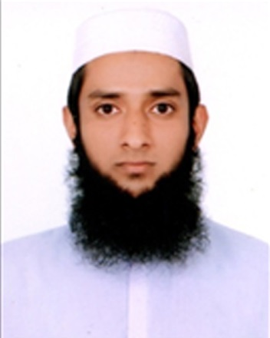**Maruf Hasan Tafsir**

Address: House: 4 Road: 4 Lane: 4 Haji Rahmat Ullah School Road, Sarulia, Demra, Dhaka.   
Cell: +88 01777419615| Email: [maruf.hasan.tafsir1997@gmail.com](mailto:maruf.hasan.tafsir1997@gmail.com)

Objective

To work in a learning and challenging environment where I can utilize my skill and ability for the personal and organizational development.

Professional Experiences

|  |  |
| --- | --- |
| **Rainbow Automation (Intern)**   * Star Delta, DOL, and reversible starter * Automatic Transfer Switch * DC power supply unit * Single Phase Transformer and Auto transformer * Solar Electrical System * Electronic Circuit Simulation & PCB design * Analogue and Digital Programming of PLC (Siemens, LOGO!) * Interfacing of different Sensor with PLC (Photo, Proximity and RTD Sensor) * Interfacing of different load with PLC (Induction Motor, Lamp, Alarm etc) * Parameter setting of (Siemens SINAMICS V-20, LS-iG5 & Delta VFD-M) inverter * Hardware testing of (Siemens SINAMICS V-20, LS-iG5 & Delta VFD-M) inverter * House Wiring Electrician | 04/2018 to 6/2018 |

Field of Skills

|  |  |
| --- | --- |
| * People management * Coordinating project/program * Excellent client communication * MS Office, Excel |  |

Educational History

|  |  |
| --- | --- |
| **Diploma in Engineering**  *(Department of Electronics Technology)*  Dhaka Polytechnic Institute | 2018 | CGPA: 3.10  BTEB, Dhaka |
| **SSC – Vocational**  Chitain Dakhil Madrasha, Narsingdi  (General Mechanics) | 2014 | GPA: 5.00  BTEB, Dhaka |

Achievements

* Trained (Electronics) by Society for Underprivileged Families
* Got awarded (first) in class eight & nine for reciting poem.
* Having skill on Islamic speech.

Language Skills

|  |  |
| --- | --- |
| Bengali- Native Speaker | English- Average in Speaking, Writing, Listening & Reading |

Personal Details

Name : Maruf Hasan Tafsir

Father’s Name : Md. Kamal Pasa

Mother’s Name : Bilkis Akter

Date of Birth : 2nd December, 1998

Sex : Male

Nationality : Bangladeshi

Religion : Muslim

Marital Status : Single

NID : 19986810720000280

Permanent address : House: 244, Village: Palpara, P.O : Islampur, Upazila & Dist : Lakshmipur

|  |  |
| --- | --- |
| Reference  **Mohiuddin Kabir**  **Executive Merchandiser and Country Manager**  **Eurasia Patchwork Bangladesh**  **House 29, Road 5, Uttara Sector 10 , Dhaka**  **Cell no: 01707669148** | **Name : Engr. Md Nuruzzaman**  **Organization : Dhaka Polytechnic Institute**  **Designation : Instructor**  **Address : Dhaka Polytechnic Institute,**  **Tejgaon , Dhaka-1208.**  **Mobile : 01716046269**  **Relation : Academic** |

**Maruf Hasan Tafsir**

**Date:**